**Team members :**

* **Bipin Singh**
* **Shubham Sharma**
* **Pranav Sharma**
* **Bibek kr. Sah**

**Software Architecture Document**

**1.0 Introduction:**

E-commerce has helped businesses establish a wider market presence by providing cheaper and more efficient distribution channels for their products or services.The objective of this project is to develop an e-commerce store where the electronics and home appliances products like T.V., refrigerator etc. can be bought from the comfort of home through the Internet.

An online store is a virtual store on the Internet where clients can peruse the inventory and select results of interest. The chosen things might be gathered in a shopping basket. At checkout time, the things in the shopping basket will be introduced as a request. Around then, more data will be expected to finish the exchange. Typically, the client will be approached to fill or choose a charging address, a transportation address, a delivery alternative, and installment data, for example, Visa number. An email notice is shipped off the client when the request is set.

**2.0 Overall Description:**

**2.1 Description:**

* Customer can register and view available products.
* Actors- Registered User, Visitors and Admin.
* Visitor can view the products
* Registered User can view and buy the products
* Admin can add products, edit product information and add/remove product.
* Admin can ship order to user based on order placed by sending confirmation mail.
* ContactUS page is available for queries.

**2.2 Web Pages details:**

* Home Page
* AboutUs Page
* Product Page
* Browse Page
* ContactUs Page
* Order Page
* ProductList Page
* OrderList Page
* UserList Page
* EditProduct Page
* EditUser Page
* EditProfile Page
* UserEdit Page
* Cart Page
* Shipping Page
* Payment Page
* Login Page
* Register Page

**2.3 Project Details:**

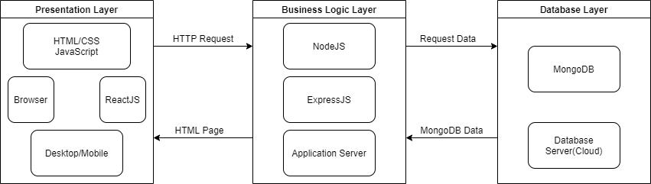

**3.0 System Requirements:**

**3.1 Use Case View:**

A use case diagram at its simplest is a representation of a user's interaction with the system that shows the relationship between the user and the different use cases in which the user is involved.

**3.2 Use Case Diagram:**

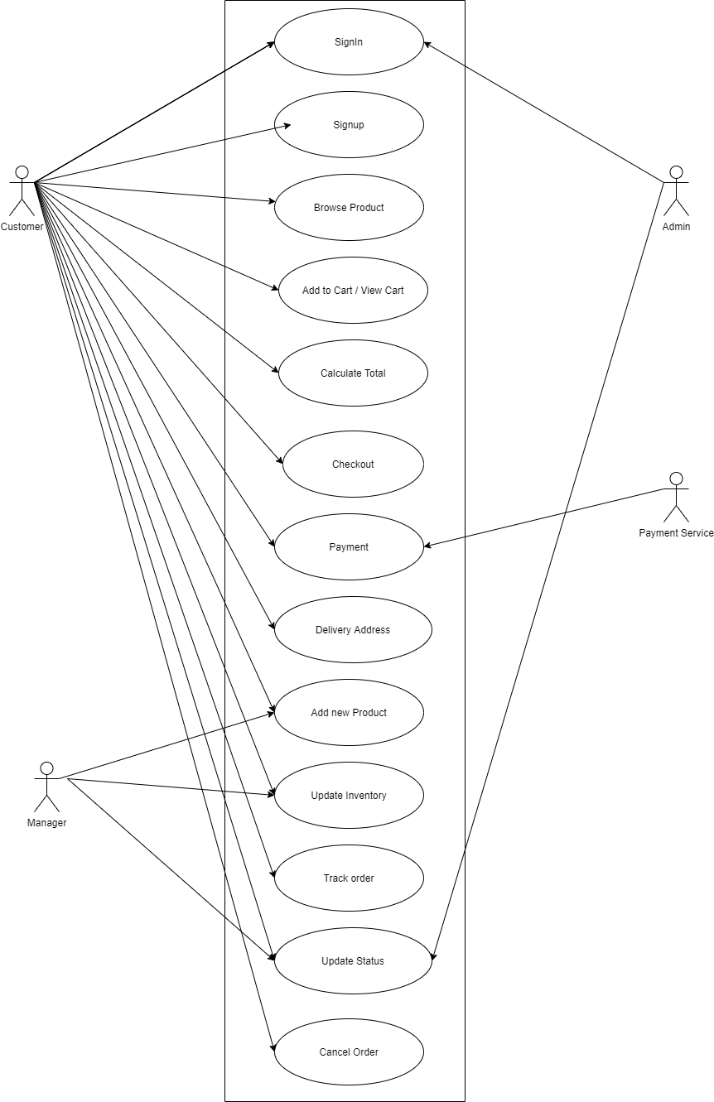

**5.0 Logical View:**

The logical view is concerned with the functionality that the system provides to end-users. [UML diagrams](https://en.wikipedia.org/wiki/Unified_Modeling_Language) are used to represent the logical view, and include [class diagrams](https://en.wikipedia.org/wiki/Class_diagram), and [state diagrams](https://en.wikipedia.org/wiki/State_diagram).

**5.1 Logical View Diagram:**

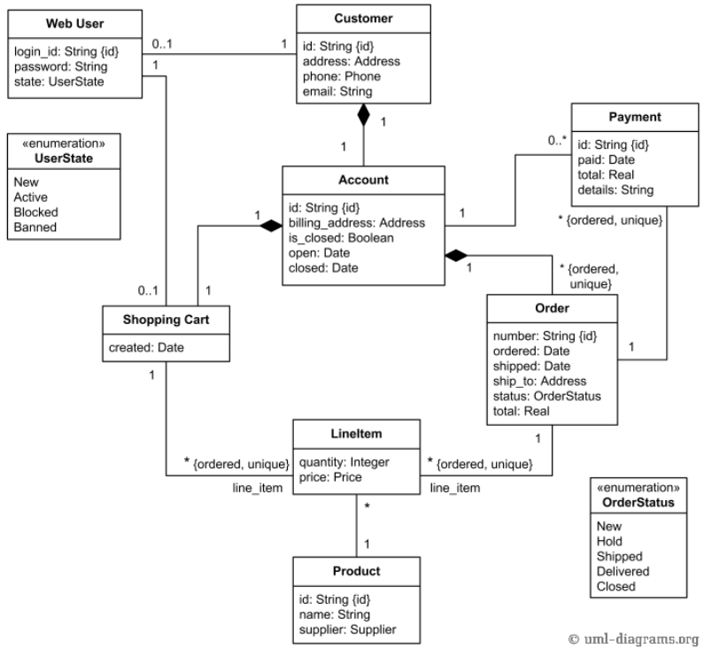

**6.0 Process View:**

The process view deals with the dynamic aspects of the system, explains the system processes and how they communicate, and focuses on the run time behavior of the system. The process view addresses concurrency, distribution, integrator, performance, and scalability, etc. UML diagrams to represent process view include the [sequence diagram](https://en.wikipedia.org/wiki/Sequence_diagram), [communication diagram](https://en.wikipedia.org/wiki/Communication_diagram), [activity diagram](https://en.wikipedia.org/wiki/Activity_diagram)

**6.1 Process View Diagram:**

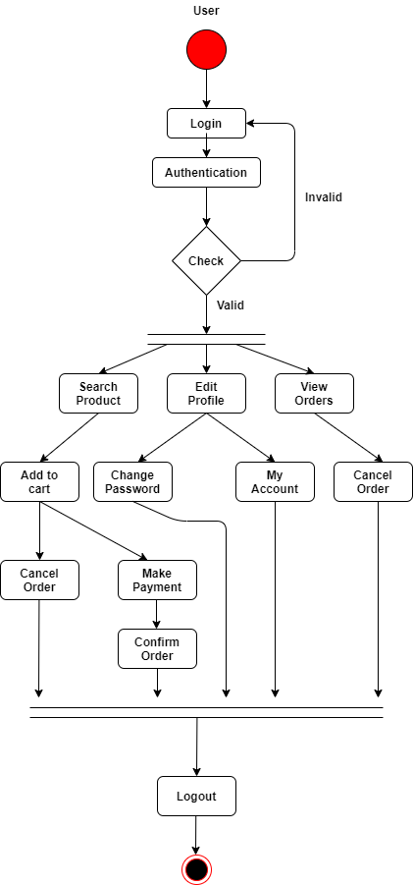

**7.0 Deployment View:**

A deployment diagram is a UML diagram type that shows the execution architecture of a system, including nodes such as hardware or software execution environments, and the middleware connecting them. Deployment diagrams are typically used to visualize the physical hardware and software of a system. Deployment diagrams help model the hardware topology of a system compared to other UML diagram types which mostly outline the logical components of a system.

**7.1 Deployment View Diagram:**

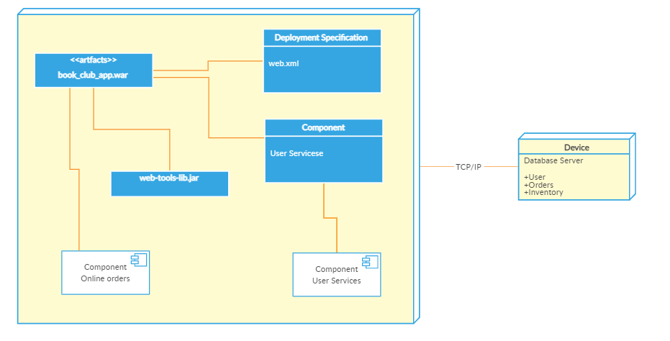

**References:**

* <https://www.ecs.csun.edu/~rlingard/COMP684/Example2SoftArch.htm#top>
* <https://zenaton.com/workflows-examples/e-commerce-check-out/>
* <https://creately.com/blog/diagrams/deployment-diagram-tutorial/#:~:text=A%20deployment%20diagram%20is%20a,and%20software%20of%20a%20system>.